This booklet belongs to:

Week D– Monday

Day at a glance:
Monday | Bushland treasures | Toy carrier | Jazz dance | Hearing rhyme | Playdough worms
Estimated time | 15-20 mins | 20-25 mins | 15-20 mins | 15-20 mins | 20-25 mins
Resources required | Leaves, sticks, paper, glue | Soft toys, towel/s, wool, string | Music | Story book | Playdough, pencil

Bushland treasures
Learning goal: Children develop a connection to and respect for our natural environment.
Watch the video via this QR code. If you can’t access the video, you can start at step 1.
- Go for a walk outside or in your yard with someone in your family.
- Like Julie-Ann does in the video, collect natural materials from the ground.
- Use what you found to create different pictures.
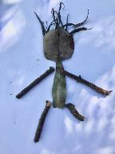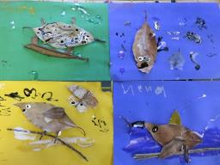
Is this activity too hard?
- If you can't go for a walk outside, use craft materials to create your picture.
Is this activity too easy?
- Describe your pictures to someone and ask them to write down what you say about each picture.

Toy carrier
Learning goal: Children persist and problem solve to complete a task.
Follow these steps to make a toy carrier:
- Collect some of your soft toys and some fabric, a towel, wool or string.
- Think about how you can make the carrier. The photos below might give you some ideas.
- Draw your ideas.
- Make the carrier and try it out. If it doesn't work, try again.
- Carry your toy!
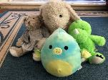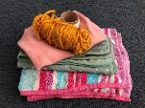

"A Woman and Child in a Baby Carrier in Guizhou, China" by Minneapolis Institute of Art is licensed under CC BY-NC-SA 2.0
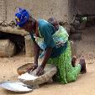
"Dogon woman with baby is grinding flour" by Erwin Bolwidt is licensed under CC BY-NC-SA 2.0
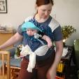
"Mei tai baby carrier, forward facing baby, in front carry" by milele is licensed under CC BY 2.0
Is this activity too hard?
- Use a small toy, this will make the carrier easier to make.
Is this activity too easy?
- Make the carrier so that you can use it without needing to hold it with your hands.

Jazz dance
Learning goal: Children engage in physical activity to stay healthy.
Watch the video via this QR code, and follow the instructions to do a jazz dance. If you can’t watch the video, you can play your favourite song at home and make up dance moves.
Is this activity too hard?
- Rather than following the instructions, make up your own dance moves.
Is this activity too easy?
- After learning the movements, perform the dance for someone.

Take a break
Here are some things you might like to do:
- have a drink of water and a healthy snack
- play or have a rest
- go to the toilet and wash your hands.
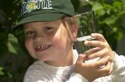
"Boy with glass of water, 2000" by Seattle Municipal Archives is licensed under CC BY 2.0
Photo by Any Lane from Pexels
Photo by Andrea Piacquadio from Pexels
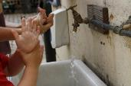
"Washing hands" by magnusfranklin is licensed under CC BY-NC 2.0

Hearing rhyme
Learning goal: Children listen to and respond to rhyme.
Listen to the rhyming activity via this QR code. If you can’t access the activity, you can start at step 3.
- As you listen, keep an ear out for rhyming words. Remember, the end of rhyming words sound the same.
- These are some of the rhyming words in the story:
  - say - way
  - Trevor - never
  - mine - swine
  - stuff - puff
  - loot - scoot
  - cry - fly.
- Find a story book you have at home. Someone in your home might be able to read it with you and help find the rhyming words in the story.
- Think of words that rhyme with each of these words below:
star
(car, jar)
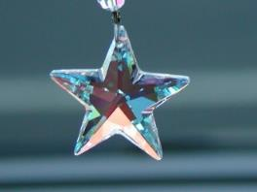
"Star" by nixternal is licensed under CC BY 2.0
cat
(mat, fat)
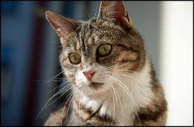
"Cat Portrait" by Dennis Ott Photography is licensed under CC BY-NC-SA 2.0
pig
(dig, jig)
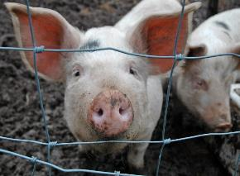
"pig" by thornypup is licensed under CC BY-NC-ND 2.0
frog
(dog, log)
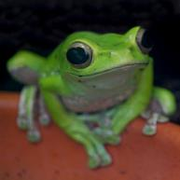
"Happy Green frog" by @Doug88888 is licensed under CC BY-NC-SA 2.0
Is this activity too hard?
- Listen to the story again. Pause and replay to check when you think you have heard rhyming words.
Is this activity too easy?
- Think of words that rhyme with these words:
  - man
  - leg
  - fit
  - stop
- Draw pictures of rhyming pairs. How many pairs did you draw?

Playdough worms
Learning goal: Children investigate measurement and use mathematical vocabulary to describe length.
Have fun playing with playdough.
- Make some worms with the playdough.
- Count your worms. How many worms did you make?
- How can you find out which worm is the longest?
- Which worm is the shortest?
- Are any worms the same or equal length?
- Line up your worms from shortest to longest.
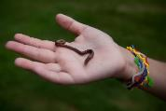
"161 | Earth Worm & Silly Bandz" by Mishelle Lane is licensed under CC BY-NC-ND 2.0
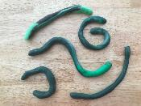
- Find a pencil:
  - Make a worm longer than the pencil.
  - Make a worm shorter than the pencil.
  - Make a worm the same or equal in length to the pencil.
- What else can you do with your playdough?
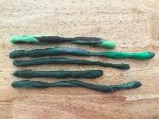
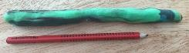
Is this activity too hard?
- Make two worms with playdough. Lay them side by side. Which is the longest? Which is the shortest?
Is this activity too easy?
- How many pegs long is your longest worm?
- How many pegs long is your shortest worm?
- Find something else to measure your worms with.

Extra learning activities
- Try some of the ABCya Pre-K online games via this QR code:
- If you can’t access the QR code, you can use your playdough lines to measure other things in your home to see which is the longest. You could use a spoon, a block or a stick from outside.
© State of New South Wales (Department of Education), 2021
The copyright material published in this document is subject to the Copyright Act 1968 (Cth) and is owned by the NSW Department of Education or, where indicated, by a party other than the NSW Department of Education.
Copyright material available in this document is licensed under a Creative Commons Attribution 4.0 International (CC BY 4.0) licence.
See https://education.nsw.gov.au/about-us/copyright for further details.

