This booklet belongs to:

Week D – Thursday

Day at a glance:
Thursday | Tiwi language | Ball run | Action songs | Shared story | More, less and the same
Estimated time | 10-15 mins | 20-25 mins | 5-10 mins | 20-25 mins | 20-25 mins
Resources required | none | Small ball/marble, scissors, tape | none | Dress ups | 12 objects such as stones/pegs

Tiwi language
Learning goal: Children learn about the wider world and develop respect for other cultures.
Listen to the podcast ‘Little Yarn’ using the QR code. If you can’t access the QR code you can start at step 3.
- Malcolm will tell you about some of the things he does with his family.
- He will then teach you some words in Tiwi language.
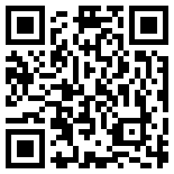
- Have a go at saying the Tiwi language word below. Ask someone to read the word below to you and you can repeat:
- “ampijini (rainbow serpent) arm-pee-gin-nee

Ball run
Learning goal: Children solve a problem through investigation and creative play.
Make a ball or marble run:
- Gather together some cardboard tubes, pipes, blocks or cardboard.
- Build a run or pathway for your ball to travel along. You might:
  - choose to tape tubes and folded cardboard together
  - start with a ramp for your ball to roll down and into a pathway made of blocks.
- How far did your ball travel? How can you get it to travel further?
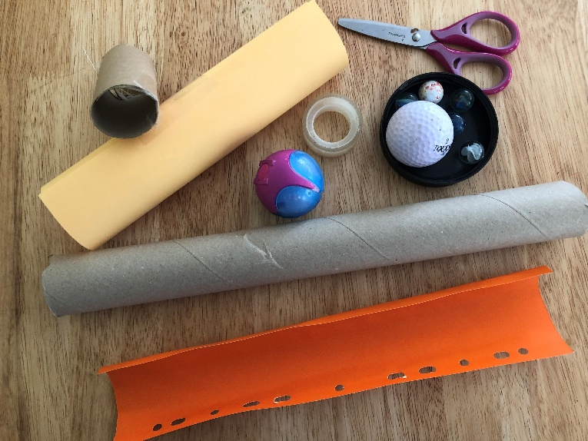

Is this activity too hard?
- Ask someone to help you build your ball run.

Is this activity too easy?
- Extend your creation so the ball travels a longer distance.
- Adjust your creation so it starts from a different height.

Action songs
Learning goal: Children sing songs and perform accompanying actions.
Join in with some songs via the QR codes below. If you can’t listen to the songs, start at step 2.
- Sing along and copy the actions.
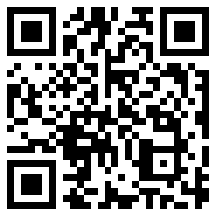
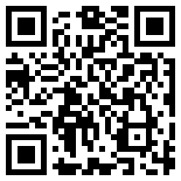
- Ask someone in your family to help you learn the words and actions of the songs using the words below:
Heads and Shoulders
Heads and shoulders, knees and toes, knees and toes, knees and toes (tap each part of your body as you sing)
Heads and shoulder, knees and toes, let’s all clap hands together
Open shut them
Open, shut them, open shut them, give a little clap (open and shut hands)
Open, shut them, open shut them, lay them in your lap (place hands in your lap)
Creep them, creep them, right up to your chin (creep them up from your lap)
Open wide your little mouth but do not let them in (open mouth but don’t let your fingers in!)

Take a break
Here are some things you might like to do:
have a drink of water and a healthy snack
play or have a rest
go to the toilet and wash your hands.
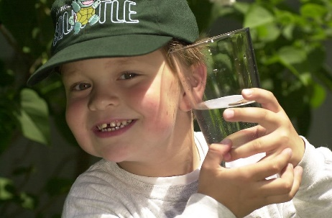
"Boy with glass of water, 2000" by Seattle Municipal Archives is licensed under CC BY 2.0
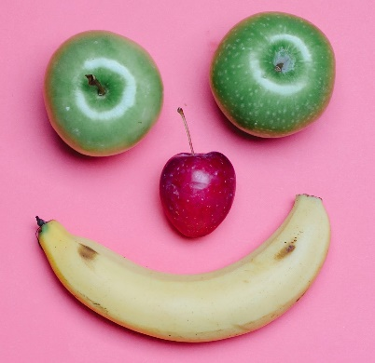
Photo by Any Lane from Pexels
Photo by Andrea Piacquadio from Pexels
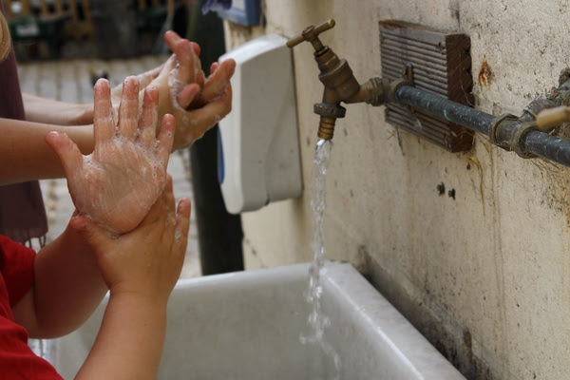
"Washing hands" by magnusfranklin is licensed under CC BY-NC 2.0

Shared story
Learning goal: Children express ideas and make meaning using a range of media.
Listen to the story ‘Why can’t I be a Dinosaur?’ via this QR code. If you can’t listen to the story, you can start at step 2.
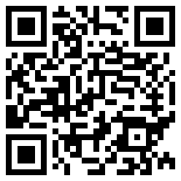
- Draw or paint Nellie dressed as a dinosaur.
- Do you have a favourite outfit you like to wear? Talk with someone in your home about it. Can you draw it?
- How do you feel when you wear your outfit?

Is this activity too hard?
- After listening to the story, dress up in your favourite costume.

Is this activity too easy?
- Do you think Nellie should have been allowed to go to the wedding dressed as a dinosaur? Talk with someone in your home about it.
- Why do you think this?

More, less and the same
Learning goal: Children compare the quantity of collections.
Watch the video to learn how to play ‘More, less and the same’ via this QR code. If you can’t watch the activity you can start at step 1.
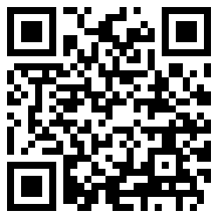
- Play the game with someone in your family (look at the photos below).
- Each person takes a handful of small objects from a container.
- Put the objects on the floor or table in front of you.
- Compare each person's collection.
- Who has more? Who has less? Or are the collections the same?
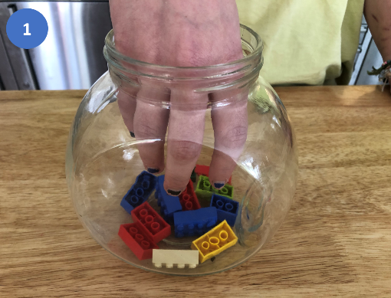
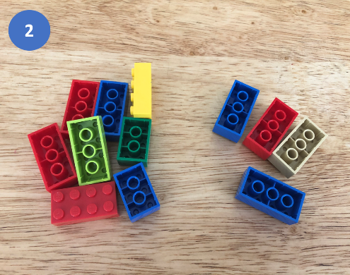
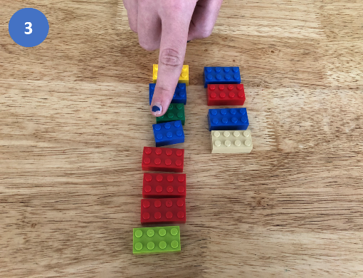

Is this activity too hard?
- Count how many objects are in each collection.
- Use your finger to touch each object as you count.

Is this activity too easy?
- Play the game again, but this time take two handfuls of objects.

Extra learning activities
Do you have a curious mind? This QR code links to many information podcasts for you to listen to. If you cannot access this QR code you might like to find a book in your home about something interesting in the world, and share it with someone in your home.
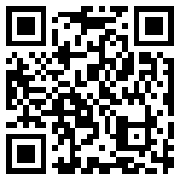

© State of New South Wales (Department of Education), 2021
The copyright material published in this document is subject to the Copyright Act 1968 (Cth) and is owned by the NSW Department of Education or, where indicated, by a party other than the NSW Department of Education.
Copyright material available in this document is licensed under a Creative Commons Attribution 4.0 International (CC BY 4.0) licence.
See https://education.nsw.gov.au/about-us/copyright for further details.

