This booklet belongs to:

Week D – Friday

Day at a glance:
Friday | Family stories | Café play | Water game | Shared story | Ducks away!
Estimated time | 15-20 mins | 25-30 mins | 20-25 mins | 15-20 mins | 20-25 mins
Resources required | Family storybook | Materials for pretend cafe | 2 buckets and 2 small containers | Something to draw with | Small toys

Family stories
Learning goal: Children develop their social and cultural heritage.
Ask a family member to tell or read you a story that is special to them. It might be a story they heard as a child themselves, or a recount of something they did as a child.
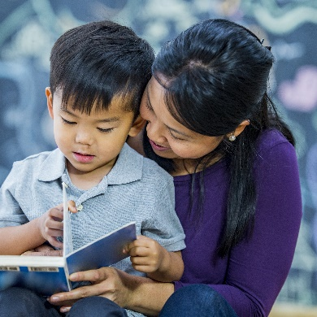
Image owned by the NSW Department of Education under the Copyright Act 1968 (Cth)

Café or takeaway play
Learning goal: Children understand that symbols can carry meaning and adopt the role of literacy user in their play.
Set up a play cafe or takeaway (you could use things like food boxes and cans from the pantry and pencil and paper to take orders)
Arrange some seating and a kitchen play area.
- Draw a list of the foods you will sell.
- Invite people in your family to come and order something from your cafe or take away.
- Prepare and serve the pretend food.
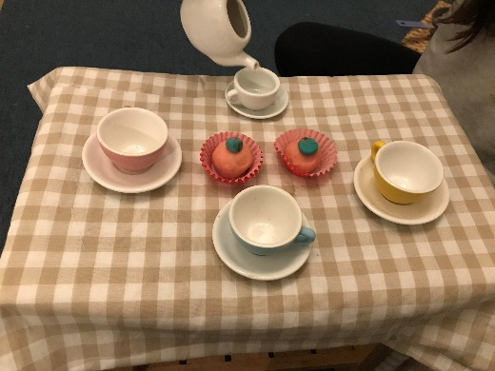
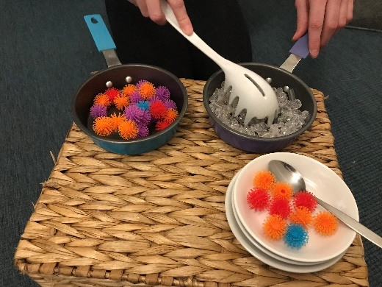
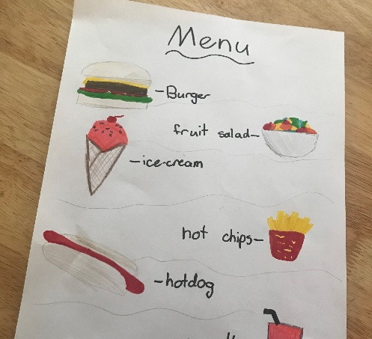

Is this activity too hard?
- Set up a kitchen corner and pretend to cook lunch or dinner.

Is this activity too easy?
- Include prices on the menu. When someone orders food, take their money and give them change.

Water game
Learning goal: Children play cooperatively.
Ask someone in your family to join you for a game with water.
- You will each need two big buckets or containers and one smaller container, like a cup.
- Outside, fill two of the big containers with water. Leave the other two empty.
- Place the two empty containers 10 steps away from the full ones.
- Race each other to tip water from the full containers into the empty ones, as quickly as you can!
- The person who fills one of the empty containers first is the winner.
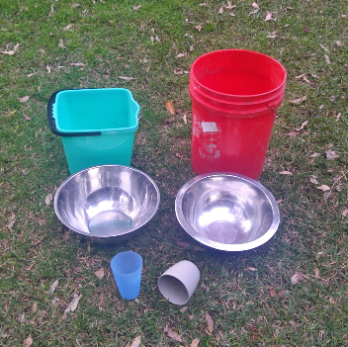
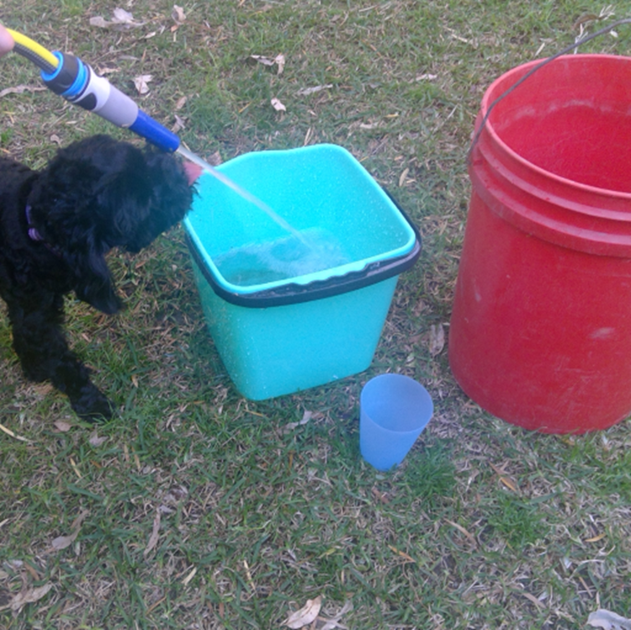
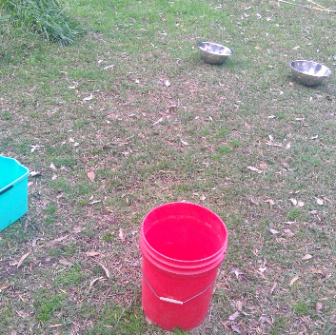
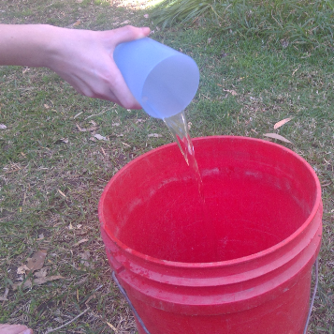

Take a break
Here are some things you might like to do:
- have a drink of water and a healthy snack
- play or have a rest
- go to the toilet and wash your hands.
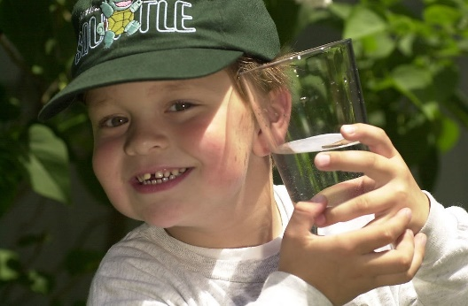
"Boy with glass of water, 2000" by Seattle Municipal Archives is licensed under CC BY 2.0
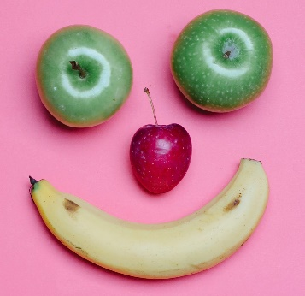
Photo by Any Lane from Pexels
Photo by Andrea Piacquadio from Pexels
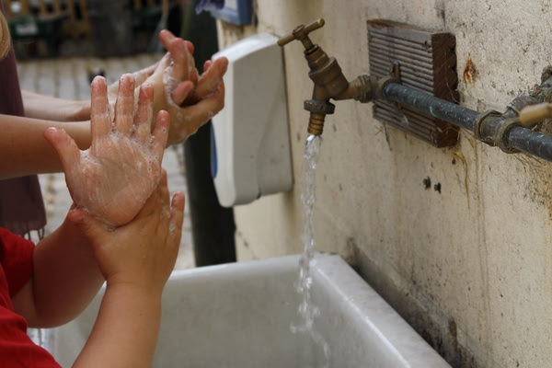
"Washing hands" by magnusfranklin is licensed under CC BY-NC 2.0

Shared story
Learning goal: Children consider the perspective of different story characters.
You can listen to the story ‘Go Home, Cheeky Animals’ via this QR code. If you can’t listen to the story, you can start at step 5.
Talk with someone in your home about the following questions:
- Who are the cheeky animals? (dogs, goats, donkeys, horses, buffalo, camels)
- What do the people want the dogs to do?
- Why do you think the dogs don't want to get up?
- The people said the dogs were lazy. Do you think the dogs were lazy?
- What cheeky animals can you think of? Can you draw them?

Is this activity too hard?
- Draw some of the cheeky animals. Who have you drawn?

Is this activity too easy?
Listen to the story again and talk to someone about the following questions:
- What did the cheeky goats do?
- What did the cheeky donkeys do?
- What did the cheeky horses do?
- What did the cheeky buffalo do?
- What did the cheeky camels do?
- What happens at the end of the story?

Ducks away!
Learning goal: Children engage with the mathematical concept of number.
Listen to the 'Ducks away!' story via this QR code. If you can’t listen, you can start at 2a.
- Retell the story using five small toys and a "bridge".
- You can watch ‘Ducks away - Follow up’ as the next step, via this QR code.
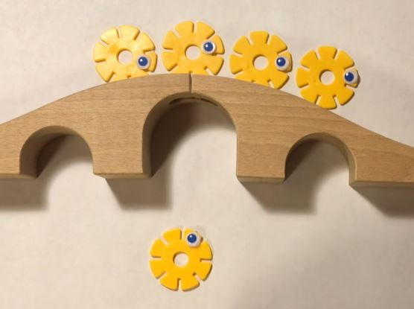
- Draw some water, a bridge and five ducks.
- How many ducks did you draw on the bridge? How many ducks did you draw in the water? How many ducks are there altogether?

Is this activity too hard?
- Sing the song Five little ducks and do the actions

Is this activity too easy?
- Do another drawing, but with more ducks.
- How many ducks did you draw on the bridge?
- How many did you draw in the water?
- How many ducks did you draw altogether?

Extra learning activities
The video via the QR code below is for families. It shows how to make simple puppets and talks about what children learn when they play with puppets. If you can’t access the QR code, you can make puppets from socks or paper bags and decorate them.
© State of New South Wales (Department of Education), 2021
The copyright material published in this document is subject to the Copyright Act 1968 (Cth) and is owned by the NSW Department of Education or, where indicated, by a party other than the NSW Department of Education.
Copyright material available in this document is licensed under a Creative Commons Attribution 4.0 International (CC BY 4.0) licence.
See https://education.nsw.gov.au/about-us/copyright for further details.

